Tour Reference / Group Name: |  |  |  |  |  |  |  |  | AVS Account No:
Contact Name:
Company Address:
Telephone Number:
E-mail Address:
Contact Preferences
Details of your booking will be held by English Heritage in line with financial regulations. Your support is helping to keep the story of England alive at over 400 historic sites across the country. We'd love to keep in touch with you about general group visits information, things to see and do, exclusive offers, our latest work and appeals. We will never share your details with anyone else to use for their purposes. You can change your mind at any time.
Please let us know how you would like to hear from us by ticking the relevant box(es): ▪ Email ▪ Post ▪ Phone ▪ SMS

 |  | Number of visitors
Date |  |  | Arrival time |  |  | Adults |  | Concessions  (65+, and Students) |  | English Heritage Members |  | Children  (5-17 incl.) | Total  (Excl. leader, driver and Members)
Admission Prices
There must be 15 or more paying visitors in your group in order to qualify for the group tour
Prices shown are before group discount. We offer a 10% discount if payment for the group is made in a single transaction. The group leader and coach driver receive free admission, but do not count towards the group number.
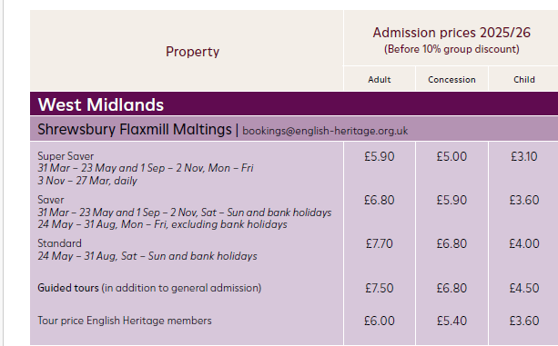
Members of English Heritage receive free admission and discounted tour prices.
Guided Tours
Tours are bookable in advance, are not offered on event days. A minimum of two months’ notice is required, and tours are dependent on availability.
Please tick the box of the tour you would like to book.
Behind the Scenes Tour
Go behind-the-scenes at this iconic landmark of the Industrial Revolution and dig deeper into the past, present and future of building that changed skylines across the world forever. You will be shown around the wider site by one of our trained volunteer guides and taken into some areas the ordinary visitor does not usually get to see! Hear the stories of the site, its history and its people from a knowledgeable guide. Have the chance to stand in the amazing atrium space of the The Kiln. Follow in the workers footsteps as you walk down the original stairs. Visit the Cross Mill and enter an unrestored floor of the building.
Tours are limited to 12 people maximum at a time, so group tours need to be booked at least two months in advance so we can guarantee our volunteer guides are ready for your visit.
Behind-The-Scenes tours involve an extended period of standing and climbing stairs, including 200-year-old stairs which have worn and eroded with time. Please get in touch if you have any concerns about this.
Mill Exhibition
The Mill exhibition on the ground floor of the Main Mill is self-guided and brings to life the story of this iconic landmark of the industrial revolution.
With digital and hands-on activities for all ages, walk one of the floors where spinning machines whirred, flax flew and barley was processed for beer to brew. Discover the lives and stories of workers, engineers, soldiers and entrepreneurs who played their part in one of the greatest heritage transformations and regenerations of all time.
From its pioneering beginnings paving the way for skylines across the world, to the campaign to save and repurpose it for future generations to enjoy, you too can now experience the incredible journey of the grandparent of skyscrapers.
It’s not so run-of-the-mill.
Combined Behind the Scenes and Mill Exhibition Tour
A combination of the two tours above. The Mill Exhibition and Behind the Scenes Guided Tour are separate products and you will need a combination ticket to experience both.
Methods of Payment:
A minimum 50% deposit is required two months in advance of your booking. Full payment can be made two weeks before the date of your visit. No refunds or changes in expected numbers can be made after receipt of this payment. Accepted forms of payment are by either BACS or cheque (made payable to the “English Heritage Trust”). If you have any queries concerning payment methods, please contact us.

Tour operators and groups who bring multiple visits a year to our historic properties, can apply in advance to join our Agency Voucher Scheme (AVS). For further details and to check eligibility, please contact our Travel Trade Team by emailing traveltrade@english-heritage.org.uk

BACS |  | Cheque

Visit Information
All group tours EH guided or self-guided must be booked in advance.
A completed enquiry form should be sent to ShrewsburyFlaxmillMaltings@english-heritage.org.uk at least one month in advance of your visit.
Tours will be booked depending on availability. If the date requested is available, confirmation of the booking will be sent.
Group Size:
Wednesday-Sunday: The maximum group size for tours is 15. Groups of more than 15 visitors will be split into smaller groups to ensure guests enjoy the tour.
Timings:
Late arrival on pre-booked tours may affect our staffing abilities to deliver the tour.

Parking:

There is no parking available for coaches or minibuses. These will be required to drop off in front of the park and then park off-site.

Catering:

Turned Wood Café has a highly reviewed vegetarian & plant-based menu. Please note that they are unable to take table bookings but the café seats approximately 100 people inside and out.

Site contact Information

Address:
Shrewsbury Flaxmill Maltings, Spring Gardens, Shrewsbury, SY1 2SZ
Phone:

Email:
ShrewsburyFlaxmillMaltings@english-heritage.org.uk

Special Events:
English Heritage offers a varied programme of events at our properties each year, with details of events listed on the English Heritage website. Please note that there may be a supplementary charge on top of the admission price, if your visit coincides with a large event. Guided tours may not be available on event days.

Supervision of Children and Young People:
Please ensure that groups of children and teenagers are adequately supervised at all times. Group Leaders take full responsibility for the supervision and behaviour of their group. Local Education Authority (LEA) and Health and Safety of Pupils on Educational Visits (HASPEV) regulations recommend, at least 1 adult per 6 children in school years 1-3 (up to 7 years); and at least 1 adult per 15 students for all other ages. Organisers are required to take appropriate measures to ensure their group visitors behave appropriately.
English Heritage reserves the right to refuse entry to any visitor, or to require a visitor to leave a site if they are in breach of any of the site’s terms of entry, or for inappropriate behaviour.

Restrictions:
Registered assistance dogs are welcome in all areas of our historic sites.
Smoking, commercial photography, flying a drone and the use of metal detectors is prohibited.

For your safety:
Please take care whilst visiting, as historic sites can be dangerous and ensure your group note any advisory signs.
Wilful damage to the monument is an offence.

Confirmation of entry for Group Visit (For office use only)
Arrival date |  | Arrival Time |  |  |  |  | Total visitors
Site Name
Group Name
Pre- booked added extras | EXTRA 1 |  | EXTRA 2 |  | EXTRA 3 |  |  | EXTRA 4
Method of payment verified? | (Please note our payment terms under “Methods of Payment” above).
Date of confirmation |  | EH Signature of confirmation

